1,学生注册event 而不是class

2， vendor sponser是一件事

3， hotel 可以删了

*Event: **eventNumber**, **eventDate**, **venueNumber**, **maxRegistration**, **enableWaitList**, **scheduleNumber**

*EventAndOrganizer: **eventNumber, organizerNumber**

*Organizer: **organizerNumber, personNumber,**

*OrganizerKeepTrackOfSession: **organizerNumber, sessionNumber**

*OrganizerSolicitSponsor: **organizerNumber, sponsorNumber**

*Session/class(selected lecture with time and location): **sessionNumber, title, topic**, **description**, **duration, levelOfComplexity, readiness** (beginner, intermediate, advanced)

*Presenter: **presenterNumber , personNumber**,

*PresenterPresentSession: **presenterNumber, sessionNumber**

*Sponsor: **sponsorNumber,** **organizationNumber**, **sponsorShipAmount, serviceDescription, tableNumber(1-10)**

//Vendor and sponsor is organization

*Gift: **giftNumber, raffleNumber, sponsorNumber,giftName**, **giftDescription**

*Raffle: **raffleNumber**, **eventNumber,**

*Organization: **organizationNumber**, **organizationName**, **address1**, **address2**, **city**, **state, country**, **zipcode, phoneNumber**

*Student: **studentNumber, personNumber**,

*StudentAttendSession: **studentNumber, sessionNumber, score**

Volunteer: **volunteerNumber**, **personNumber**, firstSQLSaturday(boolean)

*EventHasVolunteer: **eventNumber, volunteerNumber**

*Person: **personNumber**, **passAccountName,** **firstName**, **lastName**, MiddleName, **emailAddress**, **jobTitle**, companyName, department, **jobFunction**, industry, address1, address2, **city**, **state, country**, zipcode, **phoneNumer**

*Venue(会场): **venueNumber**, **country**, **state**, **city**, **venueAddress**, **venueName**, **zipCode**, **timeZone**

*Room: **roomNumber(infact identification number not regular room number)**, **venueNumber**, **capacity, roomName**

*Track: **trackNumber**, **area**

*TrackOfSession: **trackNumber, sessionNumber,**

Schedule: **scheduleNumber**, roomNumber**, description(**Registration and Breakfast, Break, Lunch, class, raffle**),** sessionNumber**, startTime,endTime**,(date is the date of the event so we don’t worry about that), raffleNumber

volunteer

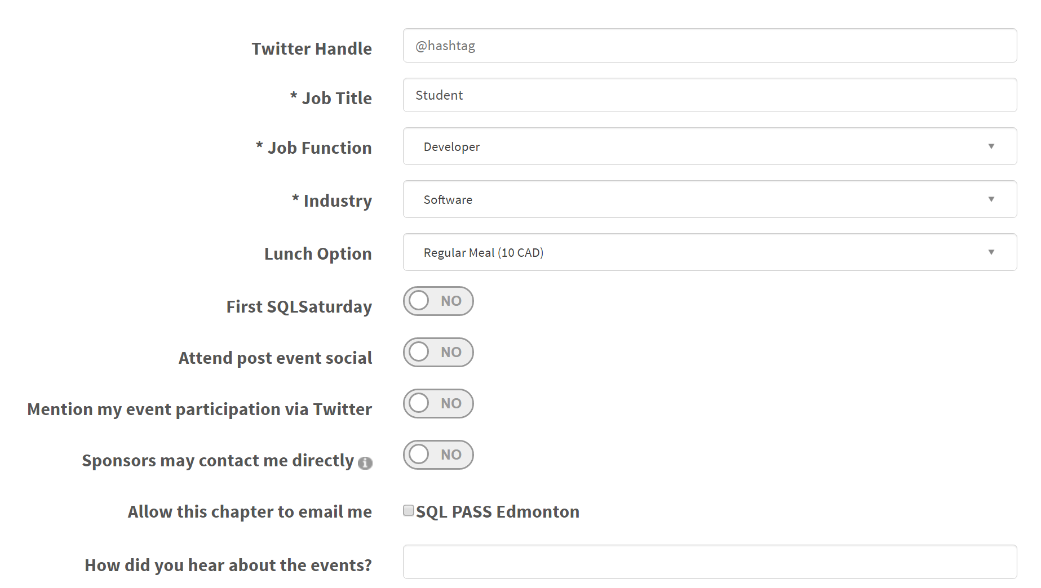

Person info

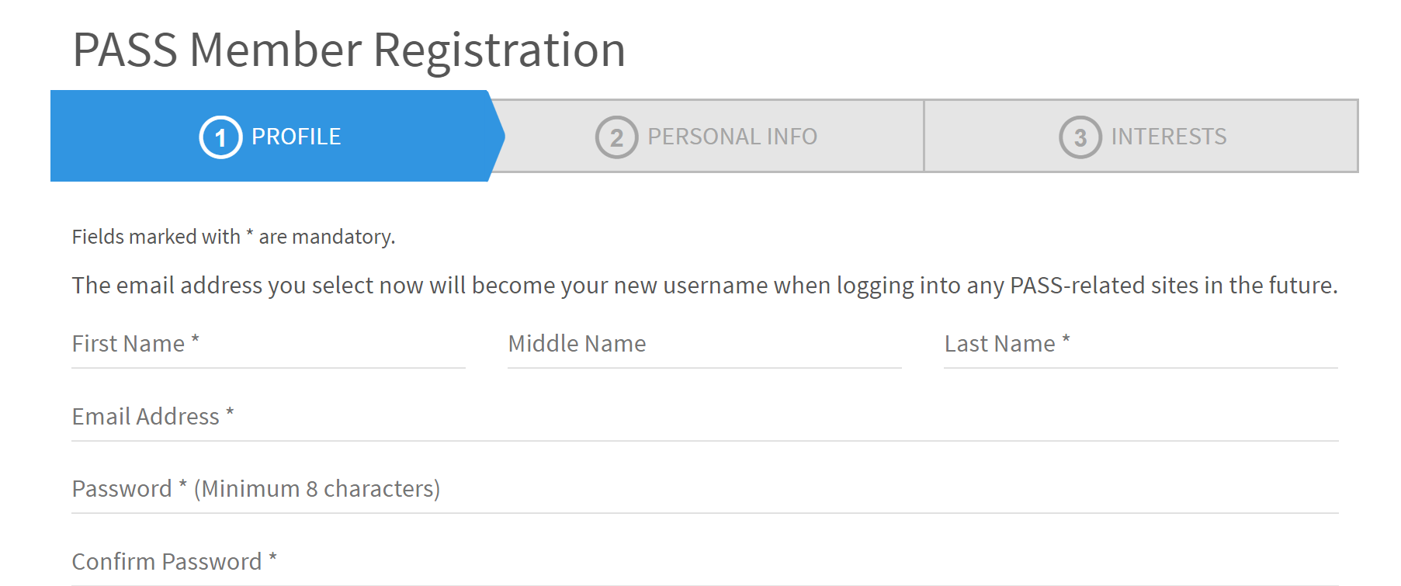

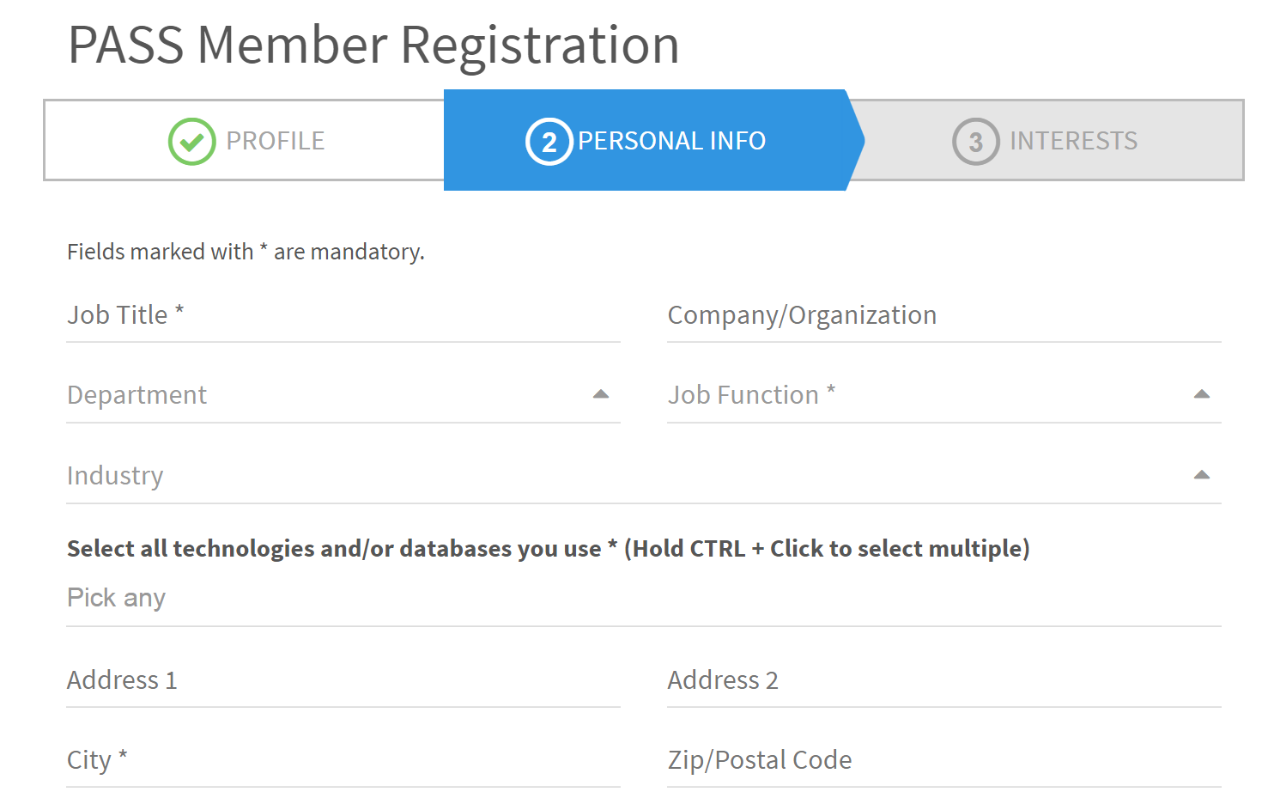

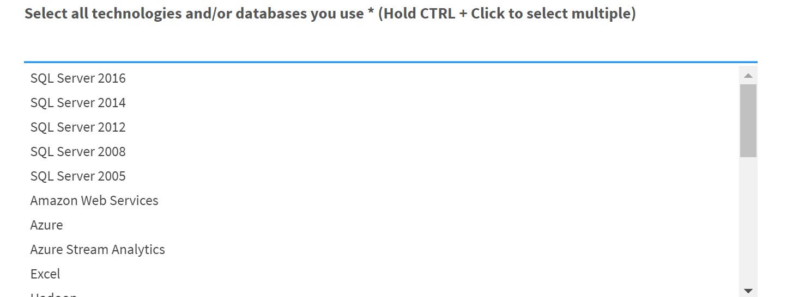

Learning preference:

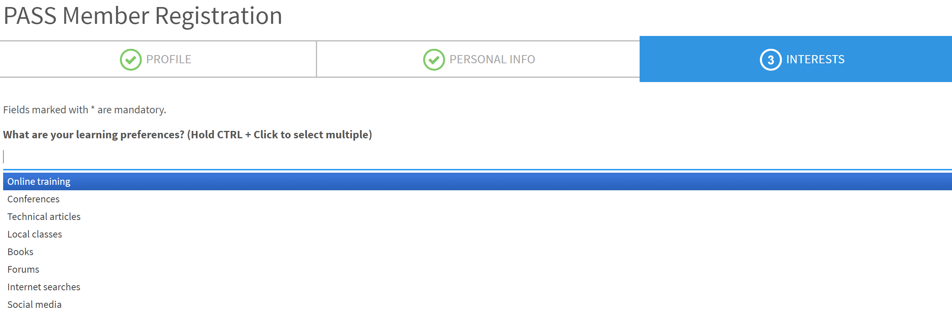

Presenter:

